WORKSHEET -10

NAME: SAI DINESH B

ROLL NO:20PW30

1.

<!DOCTYPE html>

<html lang="en">

<head>

<meta charset="UTF-8">

<meta http-equiv="X-UA-Compatible" content="IE=edge">

<meta name="viewport" content="width=device-width, initial-scale=1.0">

<title>1</title>

<link href="https://cdn.jsdelivr.net/npm/bootstrap@5.1.3/dist/css/bootstrap.min.css" rel="stylesheet"

integrity="sha384-1BmE4kWBq78iYhFldvKuhfTAU6auU8tT94WrHftjDbrCEXSU1oBoqyl2QvZ6jIW3" crossorigin="anonymous">

<script src="https://cdn.jsdelivr.net/npm/bootstrap@5.1.3/dist/js/bootstrap.bundle.min.js"

integrity="sha384-ka7Sk0Gln4gmtz2MlQnikT1wXgYsOg+OMhuP+IlRH9sENBO0LRn5q+8nbTov4+1p" crossorigin="anonymous">

</script>

<link rel="stylesheet" href="1.css">

</head>

<body>

<!-- <p class="fs-1 fw-bold" style="color: gray;">Billing Address</p> -->

<div class="container" style="background-color: rgb(241, 239, 239);">

<form class="needs-validation" novalidate>

<label for="" class="form-label" style="color:grey; font-size: larger;">Billing Address</label>

<div class="row">

<div class="col">

<div class="row g-3">

<div class="col">

<label class="form-label" for="validationCustom01">First Name</label>

<input type="text" class="form-control" placeholder="First name" aria-label="First name"

id="validationCustom01" value="" required>

<div class="valid-feedback">

looks good

</div>

</div>

<div class="col">

<label class="form-label">Last Name</label>

<input type="text" class="form-control" placeholder="Last name" aria-label="Last name" id="validationCustom02" required>

<div class="valid-feedback">

looks good

</div>

</div>

</div><br>

<div class="col">

<label for="" class="form-label">Username</label>

<div class="input-group mb-3">

<span class="input-group-text" id="basic-addon1">@</span>

<input type="text" class="form-control" placeholder="Username" aria-label="Username"

aria-describedby="basic-addon1" required>

</div>

</div>

<!-- after_username -->

<form class="row g-3">

<div class="col-12">

<label for="inputEmail4" class="form-label">Email <span class="optional">(Optional)</span></label>

<input type="email" class="form-control" id="inputEmail4" placeholder="you@example.com">

</div>

<!-- <div class="col-md-6">

<label for="inputPassword4" class="form-label">Password</label>

<input type="password" class="form-control" id="inputPassword4">

</div> -->

<div class="col-12">

<label for="inputAddress" class="form-label">Address</label>

<input type="text" class="form-control" id="inputAddress" placeholder="1234 Main St" required>

</div>

<div class="col-12">

<label for="inputAddress2" class="form-label">Address 2 <span class="optional">(Optional)</span></label>

<input type="text" class="form-control" id="inputAddress2" placeholder="Apartment, studio, or floor">

</div>

<div class="col-md-6">

<label for="inputCountry" class="form-label">Country</label>

<select id="inputState" class="form-select" required>

<option selected>Choose...</option>

<option>...</option>

</select>

<div class="invalid-feedback">

Please provide a valid country.

</div>

</div>

<div class="col-md-4">

<label for="inputState" class="form-label">State</label>

<select id="inputState" class="form-select" required>

<option selected>Choose...</option>

<option>...</option>

</select>

</div>

<div class="col-md-2">

<label for="inputZip" class="form-label">Zip</label>

<input type="text" class="form-control" id="inputZip" required>

</div>

<div class="col-12">

<div class="form-check">

<input class="form-check-input" type="checkbox" id="gridCheck" required>

<label class="form-check-label" for="gridCheck">

Shipping address is same as my billing address.

</label>

<br>

<input class="form-check-input" type="checkbox" id="gridCheck" required>

<label class="form-check-label" for="gridCheck">

Save this information for next time.

</label>

</div>

</div>

</form>

</div>

<div class="col">

<div class="col-md-4 order-md-2 mb-4">

<h4 class="d-flex justify-content-between align-items-center mb-3">

<span class="text-muted">Your cart</span>

<span class="badge badge-secondary badge-pill" id="three">3</span>

</h4>

<ul class="list-group mb-3 sticky-top">

<li class="list-group-item d-flex justify-content-between lh-condensed">

<div>

<h6 class="my-0">Product name</h6>

<small class="text-muted">Brief description</small>

</div>

<span class="text-muted">$12</span>

</li>

<li class="list-group-item d-flex justify-content-between lh-condensed">

<div>

<h6 class="my-0">Second product</h6>

<small class="text-muted">Brief description</small>

</div>

<span class="text-muted">$8</span>

</li>

<li class="list-group-item d-flex justify-content-between lh-condensed">

<div>

<h6 class="my-0">Third item</h6>

<small class="text-muted">Brief description</small>

</div>

<span class="text-muted">$5</span>

</li>

<li class="list-group-item d-flex justify-content-between bg-light">

<div class="text-success">

<h6 class="my-0">Promo code</h6>

<small>EXAMPLECODE</small>

</div>

<span class="text-success">-$5</span>

</li>

<li class="list-group-item d-flex justify-content-between">

<span>Total (USD)</span>

<strong>$20</strong>

</li>

</ul>

<form class="card p-2">

<div class="input-group">

<input type="text" class="form-control" placeholder="Promo code">

<div class="input-group-append">

<button type="submit" class="btn btn-secondary">Redeem</button>

</div>

</div>

</form>

</div>

</div>

<hr style="margin: 0;">

<div class="row">

<label for="" class="form-label" style="font-size: 2em; color: black;">Payment</label>

<div class="col">

<div class="form-check">

<input class="form-check-input" type="radio" name="flexRadioDefault" id="flexRadioDefault2" checked>

<label class="form-check-label" for="flexRadioDefault2">

Credit Card

</label>

</div>

<div class="form-check">

<input class="form-check-input" type="radio" name="flexRadioDefault" id="flexRadioDefault1">

<label class="form-check-label" for="flexRadioDefault1">

Debit Card

</label>

</div>

<div class="form-check">

<input class="form-check-input" type="radio" name="flexRadioDefault" id="flexRadioDefault1">

<label class="form-check-label" for="flexRadioDefault1">

Debit Card

</label>

</div>

<br>

<div class="row g-3">

<div class="col">

<label class="form-label">Name on card</label>

<input type="text" class="form-control" required>

</div>

<div class="col">

<label class="form-label">Credit Card Number</label>

<input type="text" class="form-control" placeholder="Last name" aria-label="Last name" required>

</div>

<p style="color: gray; opacity: 0.5; margin: 0;">Full name as on displated on card.</p>

</div>

</div>

<div class="row sm-3">

<div class="col-sm-3">

<label for="form-label">Expiration</label>

<input type="text" class="form-control" required>

</div>

<div class="col-sm-3">

<label for="form-label">CVV</label>

<input type="text" class="form-control" placeholder="eg.123" required>

</div>

</div>

</div>

<hr style="margin-top:20px">

<div class="d-grid gap-2">

<button class="btn btn-primary" type="submit">Continue to Checkout</button>

</div>

</div>

</form>

</div>

<script>

(function () {

"use strict";

window.addEventListener(

"load", function(){

let forms=document.getElementsByTagName("form");

let validation = Array.prototype.filter.call(forms,function(form){

form.addEventListener("submit",function(event){

if(form.checkValidity()==false){

event.preventDefault();

event.stopPropagation();

}

form.classList.add("was-validated")

},false)

})

},

false

)

})();

</script>

</body>

</html>

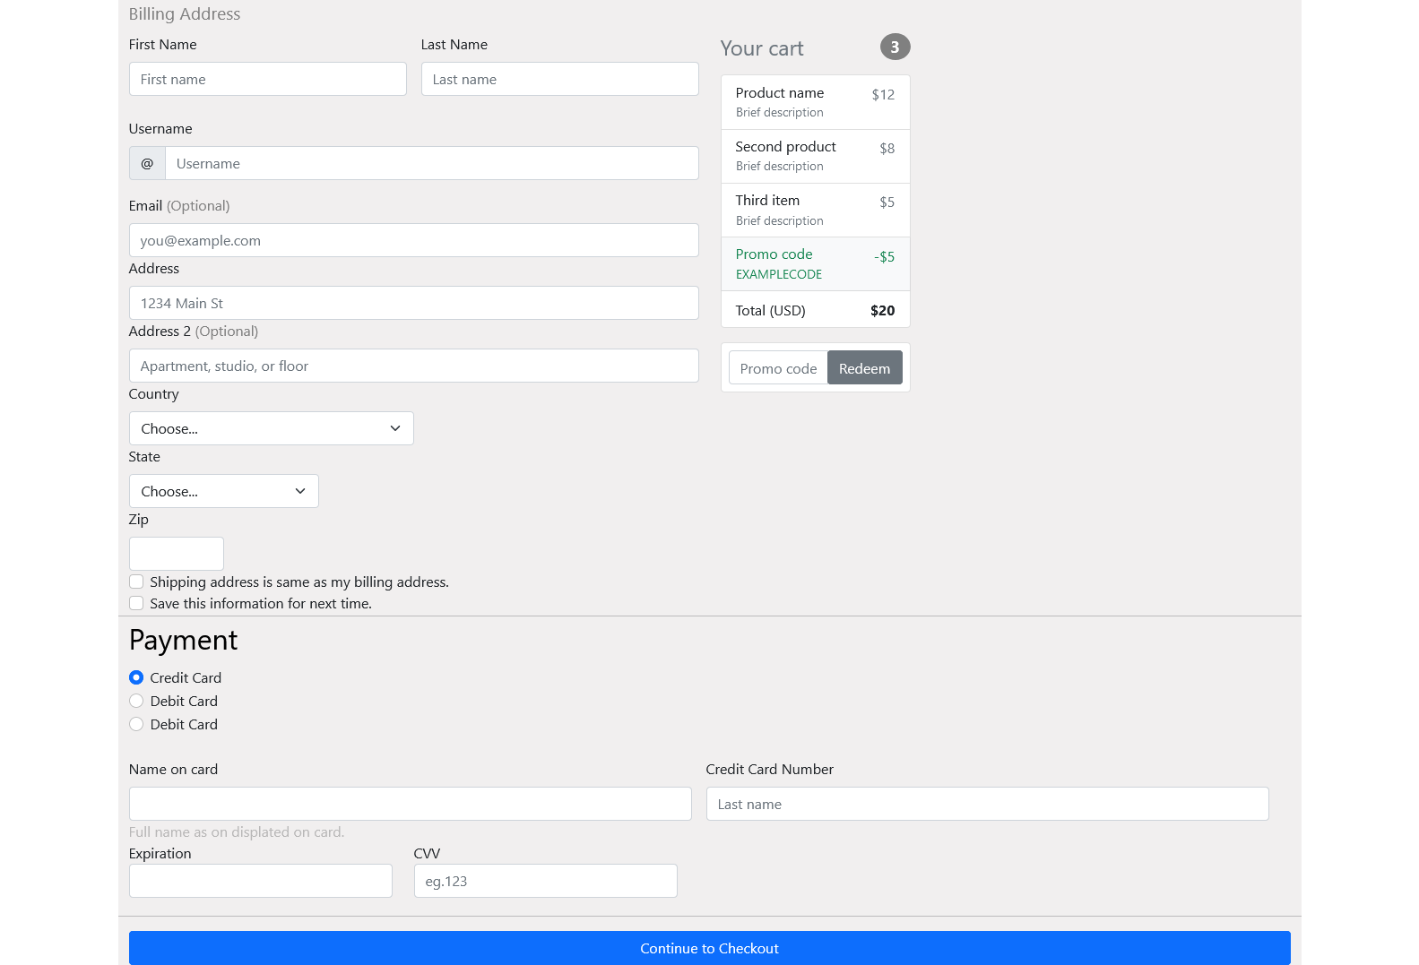

2.

<!DOCTYPE html>

<html lang="en">

<head>

<meta charset="UTF-8">

<meta http-equiv="X-UA-Compatible" content="IE=edge">

<meta name="viewport" content="width=device-width, initial-scale=1.0">

<title>Document</title>

<link href="https://cdn.jsdelivr.net/npm/bootstrap@5.1.3/dist/css/bootstrap.min.css" rel="stylesheet"

integrity="sha384-1BmE4kWBq78iYhFldvKuhfTAU6auU8tT94WrHftjDbrCEXSU1oBoqyl2QvZ6jIW3" crossorigin="anonymous">

<script src="https://cdn.jsdelivr.net/npm/bootstrap@5.1.3/dist/js/bootstrap.bundle.min.js"

integrity="sha384-ka7Sk0Gln4gmtz2MlQnikT1wXgYsOg+OMhuP+IlRH9sENBO0LRn5q+8nbTov4+1p" crossorigin="anonymous">

</script>

</head>

<body>

<div class="row">

<div class="col-4" style="background-color: orange; border: 1px solid;">

col-4

</div>

<div class="col-4" style="background-color: red; border: 1px solid;">

col-4

</div>

<div class="col-4" style="background-color:#0b9c99 ; border: 1px solid;">

col-4

</div>

</div>

<div class="row">

<div class="col-sm-4" style="background-color:#9c0b86; border: 1px solid;">

col-sm-4

</div>

<div class="col-sm-4" style="background-color:#0b319c; border: 1px solid;">

col-sm-4

</div>

<div class="col-sm-4" style="background-color:#9c0b15; border: 1px solid;">

col-sm-4

</div>

</div>

<div class="row">

<div class="col-md-4" style="background-color: red; border: 1px solid;">

col-md-4

</div>

<div class="col-md-4" style="background-color: red; border: 1px solid;">

col-md-4

</div>

<div class="col-md-4" style="background-color: red; border: 1px solid;">

col-md-4

</div>

</div>

<div class="row">

<div class="col-lg-4" style="background-color: black; color: white; border: 1px solid;">

col-lg-4

</div>

<div class="col-lg-4" style="background-color: black; color: white; border: 1px solid;">

col-lg-4

</div>

<div class="col-lg-4" style="background-color: black; color: white; border: 1px solid;">

col-lg-4

</div>

</div>

<div class="row">

<div class="col-xl-4" style="border: 1px solid;">

col-xl-4

</div>

<div class="col-xl-4" style="border: 1px solid;">

col-xl-4

</div>

<div class="col-xl-4" style="border: 1px solid;">

col-xl-4

</div>

</div>

<br><br>

<h5>Three Equal Columns</h5>

<div class="row">

<div class="col-md-4" style="background-color: red; border: 1px solid;">

col-md-4

</div>

<div class="col-md-4" style="background-color: red; border: 1px solid;">

col-md-4

</div>

<div class="col-md-4" style="background-color: red; border: 1px solid;">

col-md-4

</div>

</div>

<br><br>

<h5>Three UnEqual Columns</h5>

<div class="row">

<div class="col-md-3" style="background-color: red; border: 1px solid;">

col-md-3

</div>

<div class="col-md-6" style="background-color: yellow; border: 1px solid;">

col-md-6

</div>

<div class="col-md-3" style="background-color: red; border: 1px solid;">

col-md-3

</div>

</div>

<br><br>

<h5>Two COlumnas</h5>

<div class="row">

<div class="col-lg-4" style="border: 1px solid ; background-color: turquoise;">

col-lg-4

</div>

<div class="col-lg-8" style="border: 1px solid ; background-color: rosybrown;">

col-lg-8

</div>

</div>

<br><br>

<h5>Full Width Single column</h5>

<div class="row">

<div class="col" style="border: 1px solid;">

col

</div>

</div>

<br><br>

<h5>Nested Columns</h5>

<div class="row">

<div class="col-md-8" style="background-color: yellow; border: 1px solid;">

col-md-8

<div class="row">

<div class="col-md-6" style="background-color: yellow; border: 1px solid;">

col-md-6

</div>

<div class="col-md-6" style="background-color: yellow; border: 1px solid;">

col-md-6

</div>

</div>

</div>

<div class="col-md-4" style="background-color: yellow; border: 1px solid;">

col-md-4

</div>

</div>

</body>

</html>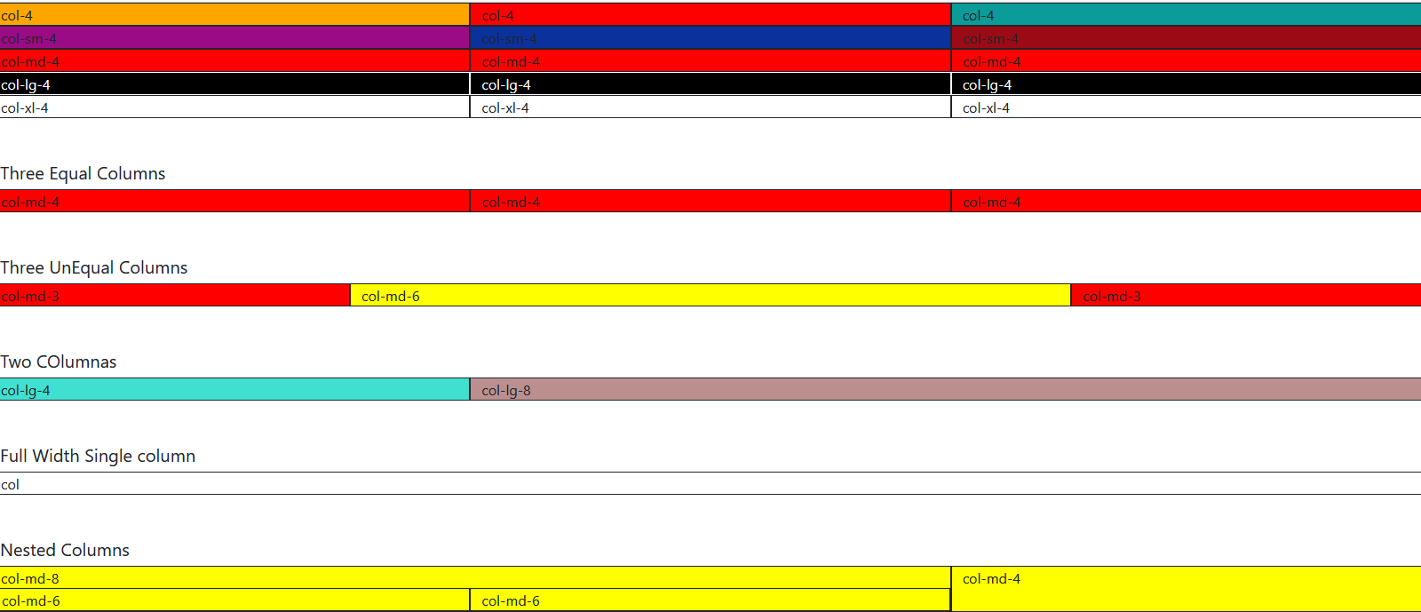

3.

<!DOCTYPE html>

<html lang="en">

<head>

<meta charset="UTF-8">

<meta http-equiv="X-UA-Compatible" content="IE=edge">

<meta name="viewport" content="width=device-width, initial-scale=1.0">

<title>Document</title>

<link href="https://cdn.jsdelivr.net/npm/bootstrap@5.1.3/dist/css/bootstrap.min.css" rel="stylesheet"

integrity="sha384-1BmE4kWBq78iYhFldvKuhfTAU6auU8tT94WrHftjDbrCEXSU1oBoqyl2QvZ6jIW3" crossorigin="anonymous">

</head>

<style>

.A{

border:solid black;

border-style:dashed;

position:absolute;

left:500px;

padding:20px;

}

</style>

<body>

<div class="A container-md-fluid">

<h1>Mariamman State Bank portal</h1>

<div class="row">

<div class="col sm-3">

<div class="form-floating mb-3">

<input type="email" class="form-control" id="floatingInput" placeholder="name@example.com">

<label for="floatingInput">Email address</label>

</div>

</div>

<div class="col lg-9">

</div>

</div>

<div class="row">

<div class="col lg-3">

<div class="form-floating">

<input type="password" class="form-control form-sm-4" id="floatingPassword" placeholder="Password">

<label for="floatingPassword">Password</label>

</div>

</div>

<div class="col lg-9">

</div>

</div>

</div>

</body>

</html>

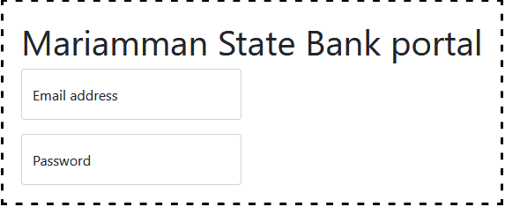

4.

<!DOCTYPE html>

<html lang="en">

<head>

<meta charset="UTF-8">

<meta http-equiv="X-UA-Compatible" content="IE=edge">

<meta name="viewport" content="width=device-width, initial-scale=1.0">

<title>Document</title>

<link href="https://cdn.jsdelivr.net/npm/bootstrap@5.1.3/dist/css/bootstrap.min.css" rel="stylesheet"

integrity="sha384-1BmE4kWBq78iYhFldvKuhfTAU6auU8tT94WrHftjDbrCEXSU1oBoqyl2QvZ6jIW3" crossorigin="anonymous">

</head>

<body>

<nav class="navbar navbar-expand-lg navbar-dark bg-dark">

<a class="navbar-brand" href="#">INDIA</a>

<button class="navbar-toggler" type="button" data-bs-toggle="collapse" data-bs-target="#navbarTogglerDemo02"

aria-controls="navbarTogglerDemo02" aria-expanded="false" aria-label="Toggle navigation">

<span class="navbar-toggler-icon"></span>

</button>

<div class="collapse navbar-collapse" id="navbarTogglerDemo02">

<ul class="navbar-nav ms-auto">

<li class="nav-item">

<a class="nav-link" href="#">contact</a>

</li>

<li class="nav-item">

<a class="nav-link" href="#">TeeSEEP </a>

</li>

<li class="nav-item">

<a class="nav-link" href="#">Download </a>

</li>

</ul>

</div>

</nav>

</body>

</html>

